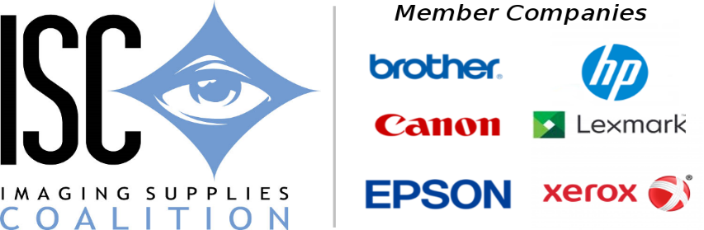

The Imaging Supplies Coalition has completed its 17th biannual conference on protecting Intellectual property in the imaging supplies industry. The conference was held September 12 to 14 at the Planet Hollywood Resort and Casino in Las Vegas, NV. The conference was international in scope attended by a diverse group of 65 professionals from 8 countries across 4 continents.

The ISC conference is noted for its presentation content as well as the opportunity for networking. The audience was not disappointed. While all presentations were excellent four were of special note. Highlighting the first day were presentations by John Shane of Keynote Intelligence on Sizing E-commerce and 3rd Party Supplies on the Internet and by Michael Sandonato of Fitzpatrick, Celia, Harper & Scinto on the doctrine of Permissible Repair. Highlighting the second day was a presentation Kristina M. Schrader of Adams and Reese and Jeff Vansteenkiste, of KSL
On the changing nature of the Dark Web and Social Media.

Conference attendees applauded the conference content as well as the opportunity to network with other brand protection professionals.
The ISC thanks all participants in the conference and looks forward to
hosting its next conference in 2020.

